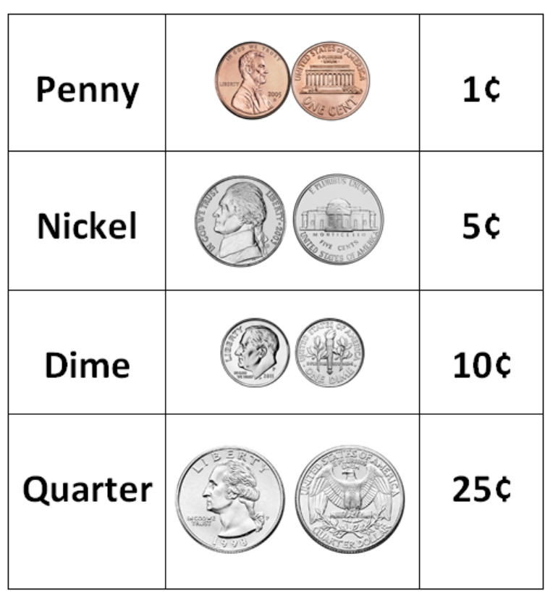

**Ridged edges!**

**Smooth edges!**